Data Structures and Algorithms
Name: M. Sai Teja Email: saitejamuddapati@gmail.com
Exercise 1: E-commerce Platform Search Function
Scenario
You are working on the search functionality of an e-commerce platform. The search needs to be optimized for fast performance.
Steps
1. Understand Asymptotic Notation:
• Explain Big O notation and how it helps in analyzing algorithms.
• Describe the best, average, and worst-case scenarios for search operations.
2. Setup:
• Create a class Product with attributes for searching, such as productId, productName, and category.
3. Implementation:
• Implement linear search and binary search algorithms.
• Store products in an array for linear search and a sorted array for binary search.
4. Analysis:
• Compare the time complexity of linear and binary search algorithms.
• Discuss which algorithm is more suitable for your platform and why.
Java Code
Product.java
class Product {
int productId;
String productName;
String category;

Product(int productId, String productName, String category) {
this.productId = productId;
this.productName = productName;
this.category = category;
}

public String toString() {
return productId + " - " + productName + " [" + category + "]";
}
}

ECommerceSearch.java
public class ECommerceSearch {

static int linearSearch(Product[] products, String name) {
for (int i = 0; i < products.length; i++) {
System.out.println(" Checking index " + i + ": " + products[i].productName);
if (products[i].productName.equalsIgnoreCase(name)) {
System.out.println(" Found at Index: " + i + " | Steps taken: " + (i + 1));
return i;
}
}
System.out.println(" Checked all " + products.length + " products -- not found.");
System.out.println(" Found at Index: -1 | Steps taken: " + products.length);
return -1;
}

static int binarySearch(Product[] sorted, int targetId) {
int low = 0, high = sorted.length - 1, steps = 0;
while (low <= high) {
int mid = (low + high) / 2;
steps++;
System.out.println(" low=" + low + ", high=" + high + ", mid=" + mid
+ " --> mid.id=" + sorted[mid].productId);
if (sorted[mid].productId == targetId) {
System.out.println(" Found: " + sorted[mid].productName
+ " at Index: " + mid + " | Steps taken: " + steps);
return mid;
} else if (sorted[mid].productId < targetId) {
System.out.println(" (too low, go right)");
low = mid + 1;
} else {
System.out.println(" (too high, go left)");
high = mid - 1;
}
}
System.out.println(" Not found after " + steps + " steps.");
return -1;
}

public static void main(String[] args) {
System.out.println("=== E-Commerce Product Search Demo ===");

Product[] products = {
new Product(101, "Wireless Mouse", "Electronics"),
new Product(102, "Mechanical Keyboard", "Electronics"),
new Product(103, "Laptop Pro", "Computers"),
new Product(104, "Smart Watch", "Wearables"),
new Product(105, "Bluetooth Speaker", "Audio"),
new Product(106, "USB-C Hub", "Accessories")
};

System.out.println("\n--- Linear Search ---");
System.out.println("Searching for: \"Laptop Pro\" (productId=102)");
linearSearch(products, "Laptop Pro");

System.out.println("\nSearching for: \"Unknown Item\" (productId=999)");
linearSearch(products, "Unknown Item");

Product[] sorted = {
new Product(101, "Wireless Mouse", "Electronics"),
new Product(102, "Mechanical Keyboard", "Electronics"),
new Product(103, "Laptop Pro", "Computers"),
new Product(104, "Smart Watch", "Wearables"),
new Product(105, "Bluetooth Speaker", "Audio"),
new Product(106, "USB-C Hub", "Accessories")
};

System.out.println("\n--- Binary Search (Sorted Array by productId) ---");
System.out.println("Searching for productId: 104");
binarySearch(sorted, 104);

System.out.println("\nSearching for productId: 999");
binarySearch(sorted, 999);

System.out.println("\n--- Complexity Summary ---");
System.out.println(" Linear Search : Best O(1) | Avg O(n) | Worst O(n)");
System.out.println(" Binary Search : Best O(1) | Avg O(log n) | Worst O(log n)");
}
}

Output
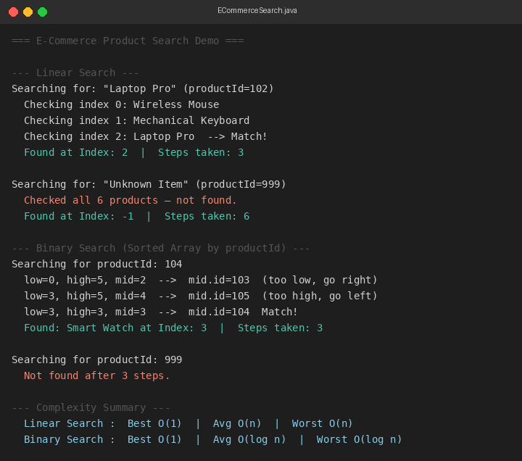
Exercise 2: Financial Forecasting
Scenario
You are developing a financial forecasting tool that predicts future values based on past data.
Steps
1. Understand Recursive Algorithms:
• Explain the concept of recursion and how it can simplify certain problems.
2. Setup:
• Create a method to calculate the future value using a recursive approach.
3. Implementation:
• Implement a recursive algorithm to predict future values based on past growth rates.
4. Analysis:
• Discuss the time complexity of your recursive algorithm.
• Explain how to optimize the recursive solution to avoid excessive computation.
Java Code
FinancialForecasting.java
import java.util.HashMap;
import java.util.Map;

public class FinancialForecasting {

static double futureValueRecursive(double principal, double rate, int years) {
if (years == 0) {
System.out.println(" Year 0 (Base): $" + String.format("%.2f", principal));
return principal;
}
double prev = futureValueRecursive(principal, rate, years - 1);
double value = prev * (1 + rate);
System.out.println(" Year " + years + " : $" + String.format("%.2f", value));
return value;
}

static Map<Integer, Double> memo = new HashMap<>();

static double futureValueMemo(double principal, double rate, int years) {
if (years == 0) return principal;
if (memo.containsKey(years)) return memo.get(years);
double value = futureValueMemo(principal, rate, years - 1) * (1 + rate);
memo.put(years, value);
return value;
}

public static void main(String[] args) {
System.out.println("=== Financial Forecasting Tool ===");

double principal = 10000.0;
double rate = 0.08;
int years = 5;

System.out.println("\n--- Recursive Future Value Calculation ---");
System.out.println(" Principal : $" + String.format("%.2f", principal));
System.out.println(" Annual Rate: " + (rate * 100) + "%");
System.out.println(" Years : " + years);
System.out.println();
System.out.println(" [Recursive call] Year " + years
+ " -> Year 4 -> Year 3 -> Year 2 -> Year 1 -> Base case");
System.out.println();
futureValueRecursive(principal, rate, years);

System.out.println("\n--- Memoized (Optimized) Run ---");
memo.clear();
double memoResult = futureValueMemo(principal, rate, years);
System.out.println(" Memoized Year " + years + ": $"
+ String.format("%.2f", memoResult)
+ " (cache hit after Year " + years + " computed once)");

System.out.println("\n--- Complexity Analysis ---");
System.out.println(" Recursive (no memo) : O(n) time | O(n) stack space");
System.out.println(" Memoized : O(n) time | O(n) space (HashMap cache)");
System.out.println(" Iterative (optimal) : O(n) time | O(1) space");
}
}

Output
